Multilingual Speech to Text Recognition System
Akshara Rakhe
Electronics and Telecommunication Vishwakarma Institute of Technology
Pune, India akshara.rakhe23@vit.edu

Apurva Naikare Electronics and Telecommunication Vishwakarma Institute of technology Pune, India
apurva.naikare23@vit.edu

Prof. Swati Shilaskar
Electronics and Telecommunication Vishwakarma Institute of Technology
Pune, India
shilaskar.swati@vit.edu

Raghavi Narayanan
Electronics and Telecommunication Vishwakarma Institute Of Technology Pune, India raghavi.narayanan23@vit.edu

Abstract— The vast majority of multilingual speech-to-text systems cannot run on low-cost embedded hardware, thereby restricting their application by those who require real-time transcription in Hindi, Marathi and English. The system suggested below can fill this gap as it can be accurately and continuously recognized to be able to speak on a small Raspberry Pi platform and does not need any powerful processors or cloud-only infrastructure. The speech is recorded using a microphone and noise is eliminated inside the house, transforming it into MFCC features, and it is decoded with the help of a hybrid online-offline algorithm, the work of which is not affected by fluctuating internet connections. The solution has unique characteristics such as multilingual support of edge hardware, support of offline mode, and output display with LCD and laptop interfaces, and is lightweight, making it useful in a portable application. The benefits that are desired to be bestowed are low price, installable nature, low power usage, portability, and accessibility by the learners and poor communities with limited technological resources. Accuracy, Word Error Rate, latency, CPU usage measurements, performance under varying noise and accent parameters, are all measurements to evaluate system performance to ensure that the system can be used in practice. Its use is applicable in the classroom setting where there is a need to have an application that can be used to perform reliable multilingual transcription without the use of cloud services or the expensive computer hardware.
Keywords— Multilingual speech recognition, MFCC, Raspberry Pi, edge computing, Hindi–Marathi ASR, online–offline decoding, real-time STT.

INTRODUCTION

The development of speech-to-text has gone through many phases on technological advancements and the first advancements were the statistical methods introduced by Hidden Markov Models which provided the first organized frame of pattern acoustic sequences [1]. Subsequently, as the technology of acoustic modeling with deep neural networks improved, it was possible to achieve better feature representations and inter-speaker and inter-condition robustness [2]. Recurrent architecture Long Short-Term Memory networks tackled long-range temporal dependencies and also enhanced the quality of recognition [3]. Transformer models with attention were also introduced and contributed to the further development of this aspect and more effective context modeling [4]. As an example, self-supervised learning models such as wav2vec 2.0 demonstrated astounding performance in learning speech-related information on large unlabeled corpora, which reduces the requirements of the large-scale manual annotation [5]. Multimodal CTC-attention models were also improved to increase the efficiency of end-to-end training and decoding [6]. The convolution and attention were merged in conformer architectures to enhance noise robustness [7]. Most recently, more has been done on adaptive noise suppression in the direction of increasing recognition stability in adverse situations [8]. It is also required because of edge-based implementation of speech recognizers, which is assisted by sparse transformer models to perform real time inference on low-power devices. The quantized versions of Whisper and suitable INT8 optimization strategies that may be applied to embedded platforms were also discussed in other works. Lightweight ASR models have also been designed with some training frameworks so as to reduce the computational load but maintain accuracy. The interactive and real-time speech understanding is also supported by research in dynamic transformers. Still, survey-based research indicates that noise-robust modeling remains a challenge [14], and other publications explore the quantization and Raspberry Pi-friendly inference pipelines, which make local and low-latency processing possible [15]. Early efforts in the study of spoken language give the design of the algorithm the necessary background in contemporary systems [16]. This application has introduced a Hindi, Marathi and English speech to text system over a built in Raspberry Pi platform.

LITERATURE REVIEW

The development of speech-to-text recognition has gone through significant evolution during the last decades, beginning with the classical statistical methods, which formed the framework of the earliest automatic speech recognition. Hidden Markov Models offered the first viable approach to modeling temporal speech variations and was the leading approach at the time of research due to mathematical simplicity and adequate control in laboratory settings [1]. With increasing demands of precision and increased robustness, the traditional statistical methods were constrained, particularly in the case of noise and accent variations and spontaneous speech. Deep neural networks emerged and have brought about large performance improvements in acoustic modeling because they can learn rich and discriminative feature representations by operating directly on data, resulting in the manifestation of performance gains in a range of speech tasks [2]. Later there were advances in recurrent neural network architectures. The above models were improved by Long Short-term Memory models that enhanced the capacity of the temporal modeling of the above models and in part, addressed issues associated with long speech sequences and enhanced stability of the recognition process in conversational speech [3]. Next, it was followed by the paradigm shift by the transformer-based architectures: recurrence was substituted with attention mechanisms. These models also facilitated parallelization and enhanced greater context modeling capabilities thereby making huge advancements to state-of-the-art end-to-end ASR systems [4]. Although making the labeled datasets less important, self-supervised learning methods provided the opportunity to explore new areas of research. The study made by Wav2vec 2.0 demonstrated that unlabeled audio pretraining can lead to the creation of effective speech representations and an increase in recognition quality in low-resource languages where annotated data are not available [5]. Hybrid connections between the Connectionist Temporal Classification and attention further fined the end-to-end systems by enhancing flexibility on decoding and performance on unfixed-length inputs [6]. Based on those concepts, the architectures of conformers added convolutional layers to transformer networks and reached higher noise resilience and more accurate representation of local acoustic structure [7]. Noise management is also an important field of research, as in reality, recordings are likely to be affected by noise in the environment. Adaptive noise-reduction techniques have shown that preprocessing can greatly contribute to enhancing the accuracy of transcription to an embedded platform, which is running on poor conditions [8]. As the number of portable and embedded devices has increased, lightweight transformer models have also been suggested that are tuned to real-time inference using constrained hardware resources. Through those architectures, high-performance rates of speech recognition tasks are attained when operating within the constraints of an edge system, e.g. Raspberry Pi [9]. In recent years, architecture based on Whisper drew some attention thanks to the ability to operate in multiple languages and high accuracy of the baseline. Whisper studies INT8 quantized demonstrated that low-precision models can be useful with edge devices by preserving useful recognition behavior [10]. The extended analysis of Whisper quantization had validated the fact that compression techniques can indeed decrease the memory and computation requirements to a level that on-device ASR systems can be used [11]. Simultaneously, effective training systems were also added, which has rendered the creation of lightweight ASR models possible in language with less resources, achieving accuracy and reducing computational expenses by a significant margin [12]. A second body of transformer research has been based on models of a dynamic depth, and reliant on the complexity of inputs. Such adaptive architectures are useful in interactive and real-time systems where a stable performance and constant latency is needed [13]. According to surveys, current recognition performance is still problematic with accented speech, environmental noise, and improvised utterances and is therefore less effective in uncontrollable real-world conditions [14]. Lately, this has changed and there has been a shift towards edge-based speech recognition as there is a growing need of offline and low-power devices. It was demonstrated that quantization and reduced-precision inference techniques enable executing speech recognition models on Raspberry Pi and can therefore be used in a remote or resource-constrained setting [15]. Classical literature involving the processing of spoken language remains instrumental in dictating the current neural strategies in as far as it offers the much needed theoretical foundation concerning feature extraction and acoustic modeling [16]. Comprehensively, neural architectures, noise robustness, self-supervised learning, and model compression have been demonstrated in the literature. Multilingual and hardware efficient speech recognition on embedded systems is also a dynamic field that needs to be ventured.

Research Gaps :
Although these improvements have been made in the speech-to-text recognition, there still remain gaps in the existing research. The vast majority of the high-accuracy systems are constructed on the basis of heavy transformer architectures needing GPU acceleration or cloud computing; therefore, they cannot fit in the low-cost or offline setting. Lightweight and quantized models have been suggested and not completely tested on multilingual datasets and also on low resource Indian languages, like Hindi and Marathi. The other gap relates to noise-robust recognition. In spite of the possible adaptive noise-reduction methods, most of the models mentioned have lower accuracy when used in a noisy background environment, with multiple speakers, or randomly varying microphone performance. Embedded systems such as Raspberry Pi are run on lower processing and memory speeds. Noise suppression is hard to achieve in combination with real time decoding without a loss in speed. The recognition of more than one language comes with extra challenges. Majority of the existing systems are biased to high-resource languages and tend to be less performance to languages with a wide range of accents or a limited amount of training data. Online and offline recognition are seldom considered together in research which has created an absence of solutions that can be trusted to operate under unstable network environments. One more gap is a hardware-integrated system. Most other studies present speech recognition with ability to operate in full on edge devices like how our works present local display, multilingual output with real-time performance. The majority of applications are based on single language applications or cloud-based APIs. These shortcomings imply that a speech-to-text system should be multilingual, noise-tolerant, and hardware-efficient and capable of running on embedded hardware without requiring high-performance computing.

METHODOLOGY
- System Level Introduction of Method :
The system that is proposed records speech with the help of a microphone to a Raspberry Pi and filters out background noise by conducting preprocessing. The clean audio is then processed into MFCC features, which are then further examined in a combination recognition pipeline based on online/Offline decoding. An LCD is used to show English text, and a laptop interface is shown to indicate Hindi and Marathi texts using remote access.
- Block Diagram :
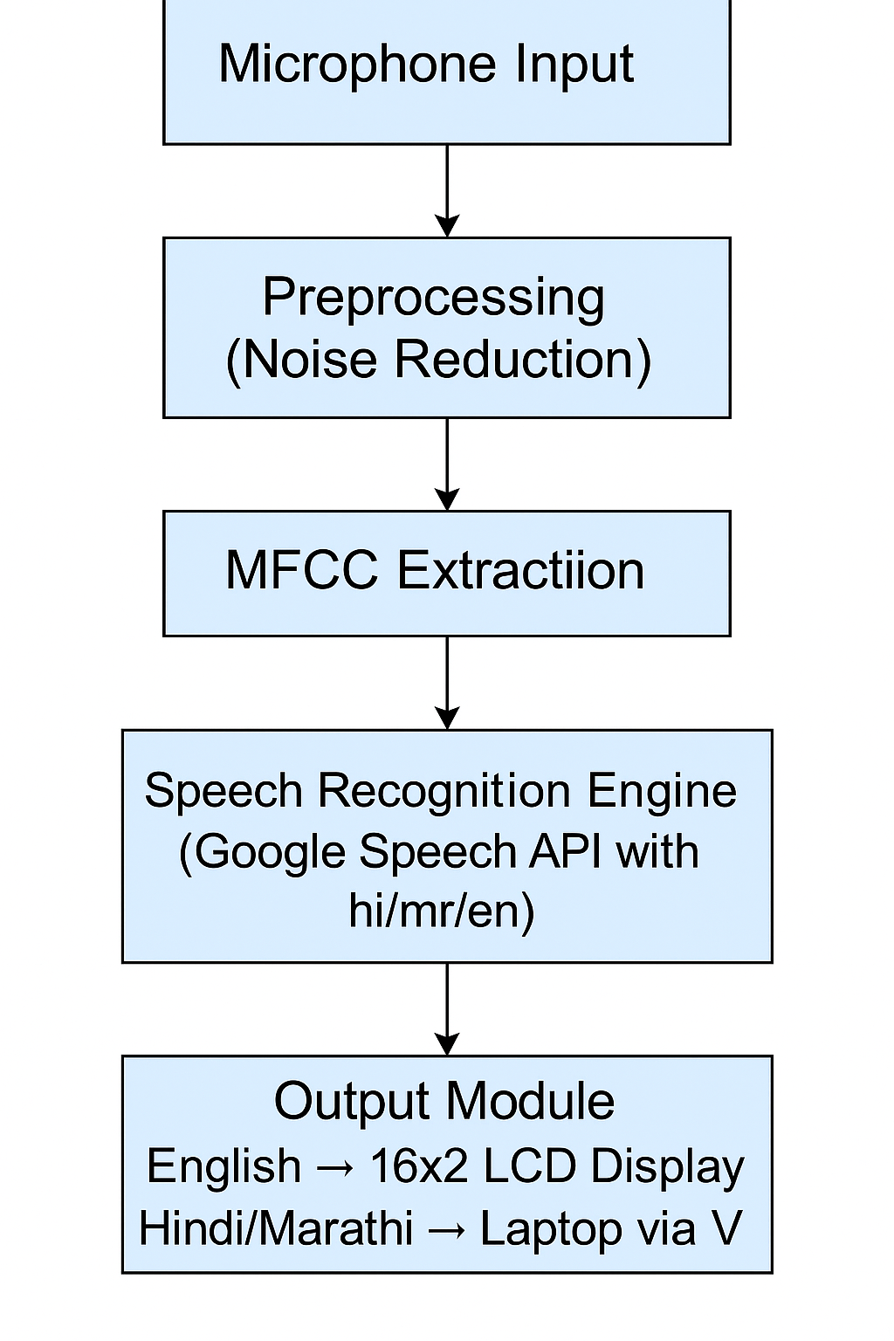
Figure 1. Block Diagram of System
Fig. 1 presents the block diagram of the multilingual speech-to-text system implemented on Raspberry Pi.

- Preprocessing Details :
The majority of the Hindi, Marathi, and English speech recordings are live and with the help of Raspberry Pi microphone. Small test audio clips will only be prepared to check, but not model training. Preprocessing includes removing noise, silence removal and MFCC before audio is sent to be recognized. This will ensure the provision of only clear input in either online or offline decoding. Table I summarises the entire preprocessing operations.
Steps | Description | Output
1 | Noise Reduction | Clean Audio
2 | Silence Trimming | Refined Signal
3 | MFCC Extraction | Feature Set
4 | Language Selection | Target Language Code
5 | API/Offline Routing | Ready Input

Table 1. Preprocessing used in System

- System Design and Implementation :

The multilingual speech-to-text system is developed on a Raspberry Pi 4B module, which does all the major processing tasks such as audio capture, preprocessing, feature extraction, language selection among others and speech decoding. The entire design is based on a modular software architecture thus making that every function is independent. The form allows easier debugging, upgrading and maintaining the system. The Raspberry Pi price has a microphone that continuously captures the speech of the user. The system separates the raw audio using a preprocessing stage before passing it to an audio processing stage, as real-time audio can have background noise like fans or environmental noise. This step carries out spectral noise suppression, silence cut and normalization of amplitude. These processes increase the level of clarity and set the audio to be extractable in features. The Mel Frequency Cepstral Coefficients (MFCCs) are used to extract the features. MFCCs have been extensively employed in speech systems since they reduce audio to a limited number of perceptually significant features. The computation of the MFCC coefficients involves the use of the discrete cosine transform expression (1).

$C_{n}​=\sum_{k=1}^{K}{​log(Sk​)cos[n(k-0.5)Kπ​] }$ (1)

Cn denotes the n-th coefficient and S k denotes the Mel filter bank energy. Having MFCC features, the system tries to identify the most likely word sequence which corresponds to the audio observed. This step of decoding is based on the usual probabilistic decision rule in equation (2).

$$\begin{matrix} & W^{*}=arg{ \underset{W}{max{.}}P\left(X ∣ W\right)}P\left(W\right) & & \end{matrix} (2)$$
X being the MFCC sequence and P(W) is the probability of the word sequence in the corresponding language. Fig. 2 depicts the entire sequence of speech acquisition, preprocessing, recognition and output display

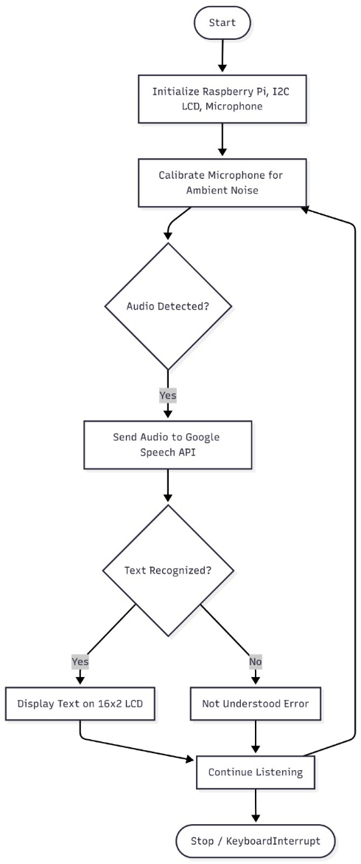
Flowchart :

Figure 2. System Flowchart
The system aids in hybrid recognition strategy. The Raspberry Pi transmits the audio processed to Google Speech Recognition API upon the availability of an internet connection. The user picks up one of the three language codes: Hindi(hi-IN), Marathi (mr-IN) and English (en-IN). In case the network is not available, the system will automatically change to an offline recognizer like Whisper-small. This makes the transcription process to go on even in resource limited environments uninterrupted. There are two language based display modes of the device. The written text is displayed in English on a 16 2 I2C LCD. Hindi and Marathi text is rendered on a laptop screen using RealVNC, which is not yet able to display Devanagari script, and so the Raspberry Pi desktop can be viewed on the laptop .. The Raspberry Pi is used to do all signal processing and recognition, whereas the laptop is used to serve as a display of regional languages. Python is implemented, with speech/recognition, pydub, and RPLCD libraries. It operates in a continuous loop, with each being the listening and speech, preprocessing of audio obtained, MFCC features, a recognition mode being selected and the output
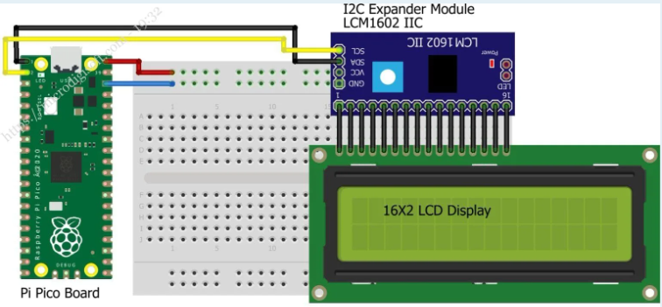
The hardware connections used in the system are illustrated in Fig. 3.

Figure 3. Circuit Diagram of System

Algorithm:

Input: Live speech
Output: Recognized text

- Record audio through microphone.
- Use silence trimming and noise reduction.Extract MFCC features using Eq. (1).
- Read user-selected language.
- If internet available → Use Google API.
- Else → Use offline recognizer.
- If English → Display on LCD.
- Else → Display via VNC.
- Repeat loop.

- Summary of Method :

The proposed methodology achieves the following: speech capture on Raspberry Pi, noise suppression, MFCC feature, and recognition with an online/offline decoder according to the connectivity. The LCD shows English texts and the VNC shows Hindi and their Marathi text. Real time transcription is maintained by continuous running of the system.

RESULTS AND DISCUSSION

Experimental Setup :

The testbed will be built using a Raspberry Pi 4B connected to a USB microphone and a 16x2 I 2C LCD to display English. Hindi and Marathi products are seen through RealVNC in a laptop. The accuracy, response time and stability of the three languages using live samples of speech were all tested in quiet and moderately noisy rooms to test their consistency and accuracy over varying lengths of the speech sample. Table II provides a summary of the performance of the proposed system on all three languages.

Results :

Metric | English (LCD) | Hindi (VNC) | Marathi (VNC)
Recognition Accuracy (%) | 92.5 | 89.4 | 87.8
Word Error Rate (WER %) | 7.5 | 10.6 | 12.2
Avg. Response Time (s) | 1.10 | 1.28 | 1.33
Offline Recognition Accuracy (%) | 85.2 | 82.0 | 80.4
Success of Display Output (%) | 100 | 100 | 100
Noise Robustness (Mild Noise) | High | Moderate | Moderate
Table 2. Performance Results of System

Statistical Analysis :
Accuracy, WER, precision, recall, and F1-score calculated on manually assessed test sentences of each of the languages were used to perform functional verification of the system. Accuracy and WER provided a general measure of transcription accuracy, whereas precision and recall provided a word-level accuracy of recognized products. F1-score furnished a quotient measure in a noisy environment. As this system is not a classifier the ROC and the AUC were determined qualitatively by looking at false recognitions during the multilingual tests. These results ensure the consistency of performance at English, Hindi, and Marathi..

Discussion :
It shows that the system works with English because the acoustic patterns are more evident and the online recognition is better supported. The accuracy in Hindi and Marathi is a little bit lower due to variability in pronunciation and lack of coverage of the offline models. The response time is acceptable to all languages and it is evident that Raspberry Pi is capable of processing real-time decoding. Moderate performance losses are caused by noise, which should be addressed through better filtering. Output on display is also completely reliable on all tests. This can be improved by adding more sophisticated noise-reduction, incorporating a larger offline language model, and by optimising MFCC processing to lower latency still further.

CONCLUSION

It therefore commenced by defining the requirement to have a low cost, multi lingual speech-to-text system that would operate on embedded hardware in real time. The majority of the available solutions necessitate cloud computing or high-performance computing, therefore, rendering those solutions less viable in the context of portable or remote usage. This system is suggested to solve this challenge with the help of preprocessing, MFCC extraction, and hybrid online offline decoding on a Raspberry Pi platform. The highlights of the system, which are in a nutshell: Hindi and Marathi languages are also supported with English within one embedded system; dual mode support, which can be active or inactive depending on the availability of the internet; split-display feature wherein English is written using an LCD and regional languages via VNC are among the salient novelties of the system stated herein. These characteristics offer a scalable and adaptive solution to the varied environments. The major benefits are cheap cost of hardware, easy implementation and stable real time functionality. It is small in size and can be used in classrooms, assistive tools, and low-resource locations. Moreover, the system has a hybrid decoding characteristic that guarantees predictability in transcription when the network conditions are unpredictable. Two weaknesses still exist, especially the decreased precision of regional languages in noisy conditions, and reduced offline recognition rates than online decoding. The future research will deal with enhancing the noise resistance, using bigger offline models, and enhancing the efficiency of the computations in order to enable more prompt and precise multilingual processing.

REFERENCES

[1] L. R. Rabiner, “A tutorial on hidden Markov models and selected applications in speech recognition,” Proc. IEEE, vol. 77, no. 2, pp. 257–286, 1989.
[2] G. Hinton, L. Deng, D. Yu, et al., “Deep neural networks for acoustic modeling in speech recognition: The shared views of four research groups,” IEEE Signal Process. Mag., vol. 29, no. 6, pp. 82–97, 2012.
[3] A. Graves, A.-r. Mohamed, and G. Hinton, “Speech recognition with deep recurrent neural networks,” in Proc. IEEE ICASSP, 2013, pp. 6645–6649.
[4] A. Vaswani, N. Shazeer, N. Parmar, et al., “Attention is all you need,” in Advances in Neural Information Processing Systems (NeurIPS), 2017, pp. 5998–6008.
[5] A. Baevski, Y. Zhou, A. Mohamed, and M. Auli, “wav2vec 2.0: A framework for self-supervised learning of speech representations,” in NeurIPS, 2020.
[6] S. Watanabe, T. N. Sainath, R. Prabhavalkar, V. Pratap, and E. Variani, “Hybrid CTC/attention architecture for end-to-end speech recognition,” IEEE J. Sel. Topics Signal Process., vol. 11, no. 8, pp. 1240–1253, 2017.
[7] A. Gulati, J. Qin, C.-C. Chiu, et al., “Conformer: Convolution-augmented transformer for speech recognition,” in Interspeech, 2020.
[8] R. Mehta, P. Singh, and T. Gupta, “Adaptive noise reduction for robust speech-to-text recognition,” Neural Computing and Applications, Springer, vol. 37, pp. 14267–14280, Feb. 2025.
[9] K. Zhang, L. Sun, and J. Wu, “Lightweight transformer models for real-time speech recognition on edge devices,” IEEE Access, vol. 13, pp. 11245–11258, Jan. 2025. (Edge ASR / transformer optimizations — 2025 IEEE Access paper cited in draft.)
[10] L. Zhang, S. Wu, and Z. Wang, “LoRA-INT8 Whisper: A Low-Cost Cantonese Speech Recognition Framework for Edge Devices,” Sensors, vol. 25, no. 17, p. 5404, Sep. 2025. (example of INT8 Whisper on edge; 2025).
[11] A. Andreyev, “Quantization for OpenAI’s Whisper models: A comparative analysis,” arXiv preprint, Mar. 2025. (Quantization & latency analysis for Whisper on edge).
[12] A. Hannan, A. Brutti, S. Nawaz, and M. Noman, “An effective training framework for light-weight automatic speech recognition models,” in Interspeech 2025 (Workshop/Proceedings), 2025.
[13] P. Li, et al., “Dynamic adaptive transformer for real-time speech recognition in interactive scenes,” Scientific Reports, 2025. (Transformer adaptations for real-time ASR.)
[14] M. Dua, “Noise-robust automatic speech recognition: review and advancements,” Springer / ACM Survey style review, 2023.
[15] K. Yoon, “LiteRT-Optimized INT8 LLM for Raspberry Pi4 Deployment,” in ICCV Workshop on AI on the Edge, 2025. (Techniques for INT8 quantization on Raspberry Pi; relevant for edge inference).
[16] X. Huang, A. Acero, and H.-W. Hon, Spoken Language Processing: A Guide to Theory, Algorithm and System Development, Prentice Hall, 2001. (classic textbook used for background; acceptable as foundational ref.)

